**The applications of terrestrial laser scanning and open source software in digital conservation**

**BY**

**Randy Howard Smith Jr**

**2043395S**



# 2013

**The applications of terrestrial laser scanning and open source software in digital conservation**

**BY**

**Randy Howard Smith Jr**

**2043395S**

**Bachelor of Arts, Environmental Science (Hood College, 2010)**

**Associates of Science, Environmental Science (Monroe Community College, 2008)**

# A thesis submitted in partial fulfillment of the degree of Master of Science in Geospatial and Mapping Science, University of Glasgow

# August 2013

Copyright © Randy Howard Smith Jr, 2013

**Abstract**

The digital conservation of historic and cultural sites provides an alternative to traditional methods of restoration. This project represents a joint venture between the University of Glasgow and the Trust, and will explore the digital conservation options available to the Trust. Through the use of digital conservation in this project, the Hopetoun House Preservation Trust will be able to conserve one of its longest standing structures, the Bruce Gates. This project has shown that the employment of current technological advances in terrestrial laser scanning has improved the methods data acquisition for historic sites. Using terrestrial laser scanning, a full data point cloud of the Bruce Gates was acquired. This project has found that difficulty in digital conservation appears in the application of acquired data and the creation of three-dimensional models and baseline data for potential degradation studies. This often requires updated infrastructure from high processing power computers to multiple software packages dedicated to the task at hand. This project investigates two software packages, the pay-for-use Leica Cyclone and the open source CloudCompare in an effort to reduce potential investment into digital conservation infrastructure by the Trust. Using terrestrial laser scanning data of the Bruce Gates, each software package was run through the procedure of registration, data cleanup, surface meshing, and model and baseline creation in a comparative study between the two packages. Through the utilization of real world data, the comparative study was able to access the full potential of each software package to digitally conserve a historic site. Conclusion of the study showed Leica Cyclone to have enhanced abilities in modeling complex structures such as the Bruce Gates. CloudCompare lacked in its abilities to produce a realistic model of the Bruce Gates. While both software packages provided basic features to register and clean data, it was determined that additional software, in terms of dedicated three-dimensional modeling packages are needed when using both Leica Cyclone and CloudCompare. In conclusion, a final recommendation was made to the Trust to utilize and communicate with the developers of CloudCompare and implement additional tools and features, specifically related to surface meshing and three-dimensional modeling, which are needed in the continued digital conservation of the Bruce Gates and the Hopetoun House Estate.

**Declaration**

I, Randy Howard Smith Jr declare that this thesis is the product of my own work, except where indicated, and has not been submitted by myself or any other person for any degree at this or any other university.

Randy Howard Smith Jr

Date

**Acknowledgements**

With completion of this Master’s Thesis, I would like to express my gratitude to everyone who provided his or her support and help. First and foremost, I would like to thank my loving wife, Jennifer, for her constant love and support throughout the past year. I would like to give my appreciation to Dr. Paul Bishop and Mrs. Anne Dunlop. Each provided valuable support and knowledge throughout the completion of this thesis. Many thanks go to the Hopetoun House Preservation Trust, specifically, Piers de Salis and Peter Burman, for there expertise and backing in the documentation of the Bruce Gates at Hopetoun House. I would like to thank my family, for their encouragement throughout this past year. Lastly, I would like to thank my parents-in-law, Barbara and David Minich, who provided editorial support throughout the writing process.

**Table of Contents**

**Title Page**……………………………………………………………………………………………………….**i**

**Abstractii**

**Declarationiii**

**Acknowledgementsiv**

**Table of Contents**…………………………………………………………………………………………..**v**

**List of Figuresvi**

**List of Tables**…………………………………………………………………………………………….…**vii**

1. **Chapter One: Introduction**………………………………………………………………………8
   1. Background to Project…………………………………………………………………………8
   2. General Aims………………………………………………………..……………………………10
   3. Objectives………………………………………………………………….……………………...11
   4. Methodology……………………………………………….…………………………………….11
   5. Project Requirements………………………………….…………………………………….11
2. **Chapter Two: Literature Review of Open Source Software and Digital Conservation** …………………………………………………………………………………………**13**
3. **Chapter Three: Review of Project Requirements**………………………………….**17**
4. **Chapter Four: Methodology**………………………………………………………...………...**19**
5. **Chapter Five: Data Production and Analysis**………………………………………...**26**
   1. Fieldwork and Data Acquisition…………………………………………………………26
   2. Registration………………………………………………………………………………………36
   3. Data Cleanup……………………………………………………………………………………..38
   4. Surface Meshing………………………………………………………………………………...40
6. **Chapter Six: Conclusion**…………………………………………………………………………**47**

**Bibliography**…………………………………………………………………………………………...…..**50**

**List of Figures**

**Figure 1. Flow Chart for creation of three-dimensional model**...........................**19**

**Figure 2. Black hole surrounding station setup**…………………………………………**21**

**Figure 3. Location of Bruce Gates within Hopetoun House Estate**…………......**27**

**Figure 4. Aerial view of Bruce Gates and station setups**……………….……...…….**27**

**Figure 5. Data acquisition from station B**……………………………………….…………..**29**

**Figure 6. Data acquisition from station C**……………………………………….……...…...**29**

**Figure 7. Data acquisition from station D**…………………………………………………..**30**

**Figure 8. Data acquisition from station E**……………………………………….…..………**31**

**Figure 9. Data acquisition from station F**…………………………………………………...**32**

**Figure 10. Data acquisition from station G**……………………………………………...…**32**

**Figure 11. Data acquisition from station H**…………………………………….…..………**33**

**Figure 12. Data acquisition from station I**……………………………………….…..……..**34**

**Figure 13. Data acquisition from station J**………………………………………...………..**35**

**Figure 14. Data acquisition from station K**………………………………………………...**36**

**Figure 15. Bruce Gates post data cleanup via Leica Cyclone**……………………...**39**

**Figure 16. Bruce Gates post data cleanup via CloudCompare**……………………**40**

**Figure 17. Leica Cyclone TIN Mesh**……………………………………………………………..**41**

**Figure 18. View of Bruce Gates looking east**………………………………………………**42**

**Figure 19. View of Bruce Gates looking west** …………………………………………….**43**

**Figure 20. CloudCompare best-fit mesh**……………………………………………………..**43**

**Figure 21. CloudCompare direct-fit mesh**…………………………………………………..**44**

**Figure 22. CloudCompare direct-fit of stonewall**……………………………………….**45**

**Figure 23. Leica Cyclone best-fit of stonewall**………………………………….…………**45**

**List of Tables**

**Table 1. British National Grid Coordinates of TLS Stations**………………………..**28**

**Table 2. Misclosure of TLS Stations**…………………………….………………………………**37**

**1. Chapter One: Introduction**

* 1. **Background of Project**

Whether it is a castle, palace, or monument, historic buildings and sites have a unique place in modern culture. Historic sites tell the story of important historical incidents, periods, events, or characters, bringing to life the history of the area in which it resides. These sites represent a tangible link between generations and promote the continuation of community education and social responsibility (Manitoba Goverment Historic Resources Branch, 2009).

In addition, these sites often add architectural value to their immediate surroundings. While the significance may vary, these sites are often rare examples of bygone and historically significant architectural styles, or they may simply enhance the beauty of the surrounding natural landscape (Hong Kong Heritage, 2012).

The true value of historic sites is to the community, city, and country to which they belong and the powerful and tangible connection they forge to the past. As such, conservation of these historic sites is crucial to maintaining their cultural significance.

Digital Conservation

Historic conservation can take many forms. The most common form is restoration to preserve the original aspects of a site. This is often necessary to halt the degradation of a site due to aging, natural phenomenon, and often, human influences (Vela et al., 2010). Restoration, however, is a costly process consuming vast amounts of resources, including funding and time. Often, the cost of restoration is inordinately high and local and national governments must make the decision to forego expensive restoration projects and leave the historic sites to degrade or rely on the assistance of private organizations. With this is mind, both public and private organizations are looking for alternatives to the traditional forms of historic conservation.

With recent developments in technology, digital conservation is now a less expensive alternative to the traditional methods of historic conservation, which included restoration (Manitoba Goverment Historic Resources Branch, 2009). The aim of digital conservation is to create digital public archives that will enable future generations to access, enjoy, and engage in the history of and conservation of historic sites. Digital conservation allows virtual access to many sensitive historic sites that otherwise are inaccessible to the public, thereby promoting public support in the management of the conservation process (Historic Scotland, 2013). This method has also been employed globally, facilitating the expansion of an international dialogue about the conservation of historic sites. Historic Scotland is a leader in digital conservation through its project, The Scottish Ten. The Scottish Ten aims to use current technology to create accurate digital models of Scotland’s five UNESCO World Heritage Sites, as well as an additional five sites located around the world (Historic Scotland, 2013). Many international universities also are employing this method to conserve historic sites in their respective countries. The Hashemite University in Jordan is quickly becoming a leading organization in the Middle East, aiming to produce digital records of desert palaces that are at risk (Al-kheder et al., 2009). The ability to digitally conserve these historic sites is becoming more feasible and making the sites more accessible.

Techniques and Technologies

The techniques and technologies used to digitally conserve historic sites are continuing to develop and have become simpler and much easier to use. Terrestrial laser scanning (TLS) is a highly reliable method for the digital capture of historic sites. Accuracies of TLS range from 0.1mm to 5mm depending on both the equipment being used and the distance from the TLS to the building. The development of this modern laser technology, in addition to the use of conventional survey practices and principles, has made it possible to collect large amounts of precise spatial data in relatively short periods of time. This has made information about historic sites obtainable, whereas in the past, this would not have been possible (Vela et al., 2010) due to time requirements and costs.

With spatial data in hand, site data can now be digitally stored and post processed. The data collected forms the “point cloud” of individual data points that represent a site. Depending on the desired resolution, the point cloud will have millions of data points at resolutions as high as 1mm x 1mm. Processing of the point cloud results in visualizations constructed from the spatially accurate data. These three-dimensional models then can be draped with high definition photographs, creating realistic representations of the historic site in its present condition (Historic Scotland, 2013). This visualization enables the public to interact with sites they may never be able to visit and creates a permanently stored public record. A historic site may disappear but its three-dimensional image will be captured for all time.

Hopetoun House

Hopetoun House was built in the early 18th century. Set in the lush country estate of the same name just outside of Queensferry, it is considered one of the finest stately homes in Scotland. Although the house was formally completed in 1707, it was remodeled and enlarged in 1721. During the 19th century, the interior was remodeled numerous times from the late Georgian style through to the Edwardian style. In 1974, the 10th Earl of Hopetoun, assisted by his father, the 3rd Marquess of Linlithgow, established the Hopetoun House Preservation Trust.

The Trust set out several objectives, one of which was “to preserve the house and grounds as a national monument and to protect and improve their amenities” (Hopetoun House Preservation Trust, 2013). Due to the efforts of the Trust, the preservation of Hopetoun House has continued throughout the years largely in the form of traditional restoration and refurbishment. Now that new alternatives for conservation are available to the Trust’s conservation management team, the creation of digital records from a TLS of the house and grounds will give the Trust the ability to preserve the site in its present state. The estate’s Conservation Assessment Report identifies the first area of interest for digital assessment as the Bruce Gates as it is one of the most degraded structures on the estate. From the data gathered, three-dimensional models will be constructed, allowing for both the digital conservation of the present state of the gates and steps and the creation of a baseline to compare and assess future site degradation.

This project conducted a TLS of the Bruce Gates at Hopetoun House and created a three-dimensional model using the spatial data. This paper also considers how a client, such as Hopetoun House, can use and apply spatial point cloud data in the absence of a survey company. In many cases, the raw point cloud data is used solely by the survey company, with the end product—the three-dimensional image—presented to the client. In a case where digital conservation is the end goal, the use, storage, and application of raw point cloud data may be a vital tool for a client with ongoing conservation needs. Viable options for the management of the raw point cloud data is contemplated as is the need to engage the client.

As a first step, two point cloud management software application are reviewed and compared. Leica Geosystems Cyclone, considered an industry standard by professionals and academics alike, is a bold option for conservative purposes as it is expensive and requires a high level of expertise to be properly utilized. The open source option, CloudCompare, has the potential to be utilized by end users, such as the Hopetoun House Preservation Trust, for digital conservation. As open source software, CloudCompare suffers from a lack of infrastructure support from a major company, which may result in lack of quality control. Drawbacks aside, the high availability, customization, and individual attention CloudCompare receives from software engineers promoting the benefits of public use make it a viable software option for conservation clients. Such viability, however, can only be determined through extensive testing, research, and the use of real data. The paper analyzes the viability of CloudCompare using data collected at the Bruce Gates at Hopetoun House to determine its ability to meet the objectives of clients such as the Hopetoun House Preservation Trust.

* 1. **General Aims**

This project has five general aims:

* + 1. To collect raw point cloud data of the Bruce Gates for the construction of a three-dimensional digital model.
    2. To collect raw point cloud data of the Bruce Gates for the construction of a three-dimensional digital model.
    3. To establish baseline data to be used to compare and assess future site degradation of the Bruce Gates.
    4. To create an initial digital record that will form the foundation for a full study of the Hopetoun House and surrounding estate.
    5. To determine the viability of point cloud management solutions as an aid to the objectives of an end user.
  1. **Objectives**

The project has three objectives:

* + 1. To collect highly accurate point cloud data of the Bruce Gates with the use of Terrestrial Laser Scanning.
    2. To create a three-dimensional model using Leica Geosystems Cyclone and CloudCompare with a comparative study of the functionality and potential applications of each software.
    3. To complete a comparative study and determine if CloudCompare is a viable alternative to Leica Geosystems Cyclone as a point cloud data management tool to aid in the objectives set forth by the Hopetoun House Preservation Trust.
  1. **Methodology**

**The following methodology was employed.**

* + 1. Acquisition of point cloud data of the Bruce Gates at Hopetoun House with TLS.
    2. Employ Leica Geosystems Cyclone and CloudCompare with post-process data using the following steps:
       1. Register multiple scans
       2. Conduct data cleanup of noise and unwanted features
       3. Create a model using surface meshing
       4. Conduct point cloud coloring using photo overlay.
    3. Conduct a comparative study of Cyclone and CloudCompare with a focus on the viability, feasibility, and application for end users with objectives related to digital conservation and deformation monitoring of historic structures.
    4. Transfer knowledge through the production of a report and poster.
  1. **Project Requirements**
* Leica Terrestrial Laser Scanner
* Survey Tripod
* Global Navigation Satellite Systems (GNSS) Receiver
* Terrestrial Laser Scanner Targets
* Terrestrial Laser Scanner Target Mounts
* External HDD
* Leica Geo Office
* Leica Geosystems Cyclone Software
* CloudCompare Software
* Access to Hopetoun House Estate
* Suitable transportation of Terrestrial Laser Scanner and associated equipment to and from Hopetoun House

1. **Chapter Two: Literature Review of Open Source Software and Digital Conservation**

Digital conservation has many aspirations in regards to historic sites. First, it aims to create realistic and metrically correct three-dimensional models to serve as digital records for future generations. Second, digital conservation provides spatial information of historic sites to be used for conservation, restoration, education, and research. Lastly, it provides management tools at the local and regional level to properly manage a historic site (Rüther et al., 2011).

Nevertheless, many issues have arisen in the campaign to create digital records of culturally and historically important sites throughout the world. For example, it is an economic struggle to provide the services and tools for digital conservation (Blue Ribbon Task Force, 2010), and the benefits are often not seen or not viewed as significant to potential stakeholders (Eakin et al., 2008). Ways to lessen the economic burden of private and public entities looking to create digital records of sites precious to them are needed. A budding solution to this economic dilemma presents itself in open source software, such as CloudCompare. Access to capable tools without the economic burden of having to purchase commercial software increases the availability of digital conservation to small sites such as Hopetoun House.

The resource of digital information is vital to research, education, cultural heritage, and public policy. For digital information to be available for future generations, provisions to preserve items that are inherently important to society must be undertaken immediately, or risk the possibility of the complete loss of information (Blue Ribbon Task Force, 2010).

Initiation is often the trickiest part of a digital conservation project. The difficulties associated with the implementation of a digital conservation project often are due to fundamental incompatibilities in the project objectives and the incentives of undertaking such a venture between the stakeholders involved in the project. Stakeholders usually are linked to three distinctive positions, the rights holders, the archivists, and the beneficiaries (Eakin et al., 2008). The roles of the stakeholders, while generally definable, often change depending on the type of project. Misunderstandings and misalignments of views between the three groups commonly occur in the conceptualization and initialization of a project. For this reason, the incentives of digital conservation need to be tailored to the shared objectives of all parties involved in a particular project (Eakin et al., 2008).

As a digital conservation project, the TLS and the modeling of the Bruce Gates at Hopetoun House faced the same issues that typically arise between stakeholders. The stakeholders involved in this project are not well defined and overlap. The Hopetoun House Preservation Trust serves as the rights holders, the archivists, and the beneficiaries of the completed the project. Initial reaction would be that as a self-serving project, all costs and incentives would be borne directly by the Trust. The research involved with the digital conservation of the Bruce Gates, however, generated interest from the University of Glasgow. The involvement of the University of Glasgow, in turn, led to further overlap in the roles of the stakeholders in the project. Due to the overlap of roles, objectives for the project were divided. The costs associated with the objectives of each entity further defined who was willing to pay for certain aspects of the project.

In the end, the University of Glasgow covered the main costs, namely data capture, model production, and the creation of a digital record. For the university, the value of producing a digital record is in the incentive for research and education in regard to TLS, digital conservation, and degradation monitoring. While Hopetoun House is the beneficiary of the work undertaken by the University of Glasgow, its role as archivist presents costs associated with maintaining and updating the digital record created of the Bruce Gates. As a privately funded entity, the cost of such upkeep may not fit within annual budgets allocated for the purposes of conservation of the Hopetoun House Estate. While all parties involved in the digital conservation of the Bruce Gates acknowledge that digital conservation has value and provides incentive to all those involved, the exploration into cost-effective ways to maintain digital records is an inherent part of the aims of this project. The development of cost-effective tools will provide support to the Hopetoun House Preservation Trust’s goal of digitally conserving the Bruce Gates. On a larger scale, the development and dissemination of cost-effective digital conservation tools may provide private organizations similar to Hopetoun House relief from the traditional financial burdens of such a project.

Open source software presents an opportunity for private organizations with limited financial resources to undertake digital conservation projects. The employment of digital conservation is financially demanding because of its complex and labor-intensive nature. Often, these factors affect the price paid for the use of software, which is priced to recoup research and development overhead. These well-developed software packages are priced out of range of what many organizations are able to invest. In a nation such as Scotland, with an abundance of cultural and historical sites in need of preservation, only well-funded organizations such as Historic Scotland have access to the appropriate software needed to support the digital conservation of their historic sites. But these well-funded organizations do not cover the full spectrum of sites that may be of public interest. Private organizations, such as the Hopetoun House Preservation Trust, are in urgent need of cost-effective digital conservation software for the purpose of documenting degrading sites of historic and cultural significance. The only way to preserve these valuable sites is through digitization before degradation means the site is no longer available for future generations (IFAP Working Group on Information Preservation, 2010).

For academic and public interests purposes, open source software presents many nuanced benefits. The first and most important is that while initially it may not fully suit the needs of a specific purpose, it can be tailored and improved to accomplish the user’s end goal. Essentially, users have the freedom to study how a program works and adapt it to their needs. Any improvements made to a program are then made available to the public (Paumier, 2009). These improvements prove beneficial to comparable organizations with similar projects. Throughout time, the software enhancements may provide other users with the opportunity to complete similar projects. In essence, the philosophy of open source software overlaps that of science (Paumier, 2009). All research is shared to contribute to an overall body of knowledge with the awareness that it can aid in the continued development of an idea, theory, or in this instance, a software package.

A secondary benefit of open source software is an increased level of efficiency. This comes from the simple fact that a user does not rely on a single person or group (Paumier, 2009). When an improvement needs to occur in a certain facet of the software, the user has the ability to make the change occur or to find a capable programmer to assist. In the case of private pay-for-use software, changes that a user would like to see happen often have to follow an approval and development scheme. Waiting on a new version of private pay software may take weeks, months, or, in some cases, years. For this reason, open source software is ideal for private organizations whose digital conservation needs do not remain static.

Finally, open source software benefits from the review and critique of novice users, as well as software engineers and digital conservation professionals. This presents a unique channel of communication between professionals and historical organizations and facilitates an open dialogue about the current limitations of the software, the future of the software, and all user-based topics and concerns in between. Pay for use software, while responding to information about system bugs, rarely considers a single user’s opinion about software improvements. It is the unique one-on-one interaction that open source software provides that enables it to suit the specific needs of so many consumers.

CloudCompare is an open source point cloud processing software that has the potential to aid in both digital conservation and degradation modeling. CloudCompare was born as a collaboration between EDF and Telecom ParisTech. Though initiated in an industrial setting, development of the software came to fruition in an academic environment, with the PhD research of Dr. Daniel Girardeau-Montaut (CloudCompare, 2012). In the early stages of development, CloudCompare dealt solely with detecting changes in data point clouds (Girardeau-Montaut et al., 2005), a function that was applied to the secondary objective of the Bruce Gates project in which a comparison of baseline data with future point cloud data was accomplished through the use of CloudCompare. In its current embodiment, the software has grown to include functions related to registration, meshing, data editing, and distance computation. In the past 2 years alone, there have been 31 software updates to incorporate new functions and features that current users need or require (CloudCompare, 2013). The evolution of CloudCompare has brought it from a simple data comparison tool, to a software package that has capabilities similar to TLS processing software currently on the market. In this way, CloudCompare has the potential to be applied to digital conservation projects.

The Hopetoun House Preservation Trust has the capability to manage, edit, and manipulate data acquired from the Bruce Gates TLS through the use of CloudCompare. CloudCompare offers an alternative to many pay-to-use TLS processing software on the market. The most interesting aspect is its possible use by the Trust to collaborate with developers who can tailor CloudCompare to meet both their current and future needs. The development of a bespoke solution for the Trust, through the use of open source software, is not unique. Many private organizations exploring digital conservation solutions have walked similar paths. Current trends show that it is economically efficient and can provide significant returns on the small investments made to develop such systems (IFAP Working Group on Information Preservation, 2010).

In addition to the gains that can be made by the Trust, developments in digital conservation facilitated by the use of open source software will provide supplementary benefits for similar organizations. These similar organizations may reach out to the Trust for their expertise and understanding of the tools used throughout this project as they embark on their own digital conservation projects. As is the philosophy of open source solutions, all developments are subsequently published and readily available for utilization. So as the aims and objectives of the Trust develop, the opportunity for them to accomplish what is set forth is available to other users. The utilization of software such as CloudCompare may be in the best interests of the Trust. But to have confidence in open source software, its capabilities and accuracy must be evaluated and compared with commercial, industry-standard packages. The latter is one of the objectives of this project.

1. **Chapter Three: Review of Project Requirements**

The TLS of the Bruce Gates at Hopetoun House presents numerous requirements for all parties involved. The requirements range from the use of field survey equipment and three-dimensional modeling software, to full access to the site. Each requirement is crucial to the success of the project. The careful coordination of resources from the University of Glasgow and Hopetoun House was necessary, and a critical review of the requirements was completed to assure all parties have the capability to complete the proposed project.

Though the project requirements laid out in Chapter 1, Section 4, are central to the project, the requirements of Hopetoun House also must be taken into consideration. Prior to any fieldwork, a meeting to determine the needs of the client was scheduled. A careful explanation of the aims of the project was given to the representatives of the Hopetoun House Preservation Trust. Due to the fact that the Trust was not familiar with the intricacies of TLS, descriptions of the capabilities and limitations of the equipment were provided. This included a summary of the resolution capability in association with building degradation, the construction of a three-dimensional model, the size and storage of the raw data captured, and an overview of the potential applications of such raw data. The end products desired by the representatives of the Trust were determined to be a photo realistic three-dimensional record of the Bruce Gates, including the geo-referencing of all data captured. The data will provide records of the gate in its current state, a baseline for future degradation studies, and a visualization of the Bruce Gate to be used for promotional items by the Trust. In addition, the raw data captured through TLS will be available to the Trust should they have future applications for such data. With the requirements set forth by the Trust, a set of project requirements were finalized.

It should be noted that the University of Glasgow provided notable resources for the completion of the project, including several pertinent field survey instruments. The use of a Leica Geosystems ScanStation C10 Terrestrial Laser Scanner was central to achieving both the Trust’s objectives and the University’s objectives. As this project is a study of digital conservation and building degradation, high-resolution data capture was needed. The degradation of historic sites is often a very slow process and changes often can only be measured in millimeters over a period of a year. Bearing this in mind, an instrument capable of capturing data of this resolution was needed. The ScanStation C10 provided the required resolution of 1mm x 1mm, ranges of up to 300 meters, and the ability to capture up to 50,000 data points per second. The capabilities of this instrument made it an ideal match for the objectives of the project.

A GNSS receiver also was required because of the need to accurately geo-reference the data points captured by the TLS. Geo-referencing the data accomplished several things. Firstly, and most simply, geo-referencing falls in line with one of the requirements set forth by the Trust. Secondly, it establishes a digital database of the Hopetoun House Estate. The data captured of the Bruce Gates can be combined with any future terrestrial laser scans of Hopetoun House to build a comprehensive digital record of the estate. Lastly, geo-referencing allows for degradation studies to take place without the need for permanent markers to be installed at each TLS site in the vicinity of the Bruce Gates. In addition to the ScanStation C10 and GNSS receiver, all equipment associated with these instruments was needed, including tripods, targets, and mounts.

The resources provided by the University of Glasgow were not limited to field survey equipment. The accessibility of several different software packages also was necessary. The software packages included the Leica GeoOffice, Leica Cyclone, and CloudCompare. The use of Leica GeoOffice is necessary only as a means to download data from the ScanStation C10. While limited in use, it is vital in its role to transfer and properly format the raw spatial data collected from the work completed in the field. The software packages Leica Cyclone and CloudCompare were used for the majority of the work for this study. Both are three-dimensional modeling software packages capable of registration, data cleanup, and modeling. Notably, the acquisition of Leica Cyclone licenses came at a cost to the University of Glasgow but are needed to properly utilize the software. Conversely, CloudCompare is free, as it is open source software. As such, it can be installed with relative ease on either a University-provided computer or a private laptop.

Minimal provisions are were provided by the Hopetoun House Preservation Trust. The primary provision was full access to the Bruce Gates. During the meeting with the Hopetoun House representatives, site access was made clear and possible dates for the fieldwork to be completed were discussed in full. Arrangements for the fieldwork were successfully scheduled in conjunction with the availability of the University of Glasgow’s field survey equipment and technicians. Due to the fact that the Bruce Gate provide access between the western and eastern grounds of the estate, it was vital to keep the path free and clear for tourists visiting the grounds. Effectively, this posed only a minor inconvenience because the Bruce Gates were only completely closed for a short portion of the TLS process. Synchronization of purpose between the Trust and the University was effortless and effective communication accommodated the completion of fieldwork.

The success of the project was a result of the coordination of resources between Hopetoun House and the University of Glasgow. The use of pertinent field survey equipment and software packages, in addition to the access provided at Bruce Gates, ensured that all project requirements were met and the aims and objectives of the study were accomplished.

1. **Chapter Four: Methodology**

The application of digital conservation is complex in its methodology, which is exacerbated with the introduction of TLS as the primary method of data acquisition. This method, while supported, poses certain challenges to the process of data acquisition. Conversely, the use of TLS to create digital records of historic sites, such as the Bruce Gates at Hopetoun House, is seen as an exciting and new technology, which will produce “future-proof” end products. However, the production of data for planned applications, such as that of degradation monitoring, exposes the complexity of such a project. Due to this complexity, a review of the methodology to document the process from data acquisition to production is provided to uncover both the rewards and shortcomings of TLS for digital conservation.

The production of three-dimensional models through TLS follows a general process regardless of the subject matter. Figure 1 shows the processes for a project utilizing TLS.

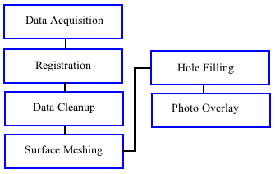

**Figure 1. Flow chart for the creation of three-dimensional model**

While Figure 1 represents a general process flow, each individual procedure includes its own set of steps. Often these steps are not as straightforward as they might appear as every project presents its own set of challenges that must be solved by troubleshooting each unique procedural step.

Data Acquisition

The acquisition of data is the first step in the TLS process and often the cause of complications in future steps. Thus, data acquisition must be carefully thought through to ensure smooth production throughout the project. A small mistake in data acquisition can cause countless hours of troubleshooting in the data production stages.

As this project involved both digital conservation and the creation of a baseline for future degradation studies, resolution of the laser scans was considered. For general digital conservation purposes, a high resolution might not be necessary to the project. In the digital conservation of A’Famosa, a stone fortress with little ornate or detailed features located in Malaysia, resolutions of 2cm were used in the scanning of the structure (Chee Wei et al., 2010). The objective of the project at A’Famosa was simply to create a digital record of the site, thus the laser scan resolution only needed to be high enough to capture the stone structure.

The Zamani Research Group, based at the University of Cape Town, has completed more than 6,000 scans of buildings, rock shelters, and landscapes. Through their experience, the resolutions generally used for buildings have been 1cm to 2cm (Rüther et al., 2011). If the scanning of the Bruce Gates at Hopetoun House were only for digital conservation purposes, resolutions would fall in the general ranges of 1cm to 2cm. However, future degradation studies needed to be considered. Degradation and subsidence often are a very slow process. For Hopetoun House, natural weathering is the main cause of degradation and subsidence of the Bruce Gates mainly because of its location in eastern Scotland where it is not exposed to numerous sudden natural disasters. For this reason, it can be theorized that normal degradation to the site will be measurable with laser scanning to less than 1cm, barring any catastrophic natural occurrences during a period of one year. More specifically, the resolution of the Bruce Gates was set at 2mm with a distance of 10 meters.

The consideration of potential setups and the positioning of the TLS is a crucial element of any data acquisition fieldwork. Preplanning the setups is imperative and in many cases, is necessary to develop a broad-spectrum impression for how the setups will progress. However, it is important to note that off-site preplanning often has to change once on the ground in response to factors that cannot be covered in a two-dimensional plan or satellite image view. One of the most important considerations once on-site is the field of view of the laser scanner (Rüther et al., 2011). The architecture of many historic buildings and estates is often unforeseeably complex, complete with intricate and ornate fixtures. In addition, protruding walls, independent columns, and railings often cause a shadow effect, which can affect the amount of data available for the backside of a particular feature. Due to this shadow affect, multiple setups and scans may need to be completed to fully capture a particular feature. The available field of view once on site also can inhibit the lower angular limits of the scanner. For example, the laser scanner used to scan the Bruce Gates, has a downward angular capture limit of 45 degrees. As a result, a black hole of data surrounds the area of the setup. Figure 2 shows the black hole the ground of Hopetoun House that occurred during a test scan.

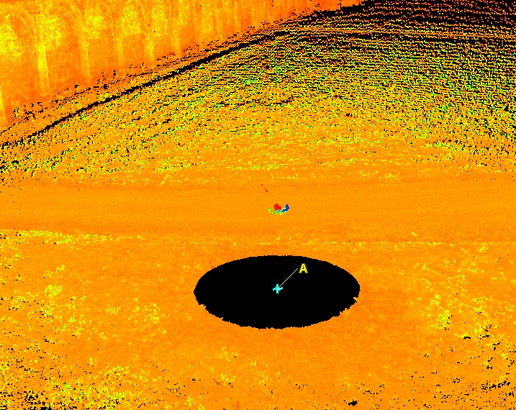

**Figure 2. Black hole surrounding station setup**

Careful placement of the scanner in relation to the object of interest must be considered. Placement of the scanner too close to an object may lead to loss of data from two potential sources. The first source of lost data is the black hole (Figure 2), which demonstrates how the lower limitations of the scanner’s recording angle cannot capture data in its immediate vicinity. The second source of lost data is caused by the proximity of placement of the laser scanner to a tall structure causing oblique laser beams. A laser scan of Black Gate, located in Newcastle-upon-Tyne, lost data on the upper reaches of the structure due to placement of the scanner in close proximity to the structure. The occurrence of oblique laser beams increased on the upper reaches of the structure, in turn causing a decrease in the amount of data captured (Kimpton et al., n.d.). Conversely, placement of the laser scanner too far away from a structure also may affect the data capture and result in unwanted or limited-use data, leading to additional time spent on data cleanup.

In addition to considering the field of view in laser scanning, obtaining scans with areas of overlap is necessary. Overlapping scans serve two vital purposes: all data is captured fully for the area and for the ease of registration of the point clouds should there be any unforeseen issues. For these reasons, manual registration by point picking must be undertaken.

The final number of scanner setups at the Bruce Gates was based on a number of factors and was impacted by the complexity and overall size of the structure (Rüther et al., 2011). The Bruce Gates, while a relatively simple structure when compared to the complexity of the surrounding estate, presented multiple physical barriers that affected the accuracy of the laser scanning. The physical barriers surrounding the Bruce Gates include hedges, fences, and posts that resulted in an increase in the number of scans. This issue has been encountered in similar projects, such as the digital documentation of African Heritage Sites by the University of Cape Town. The experience of the University of Cape Town laser scanning team has demonstrated that to fully capture historic sites, an increased number of scans is often necessary (Rüther et al., 2011). Considering the time constraints placed on the fieldwork at the Bruce Gates, the number of scanner setups needed to be optimized to account for time efficiency and maximum data capture.

Registration

Determining the method by which the scans are registered impacts future data production. The early stages of the process for three-dimensional model creation are impacted by registration, which is the transformation of all scans taken during a project into a single and uniform coordinate system (Rüther et al., 2011). There are three different methods of registration, each with potential advantages. The first utilizes a setup with overlapping sets of targets in each scan. The targets act as a point of reference, allowing for multiple scans to be linked together. However, on large sites, such as the Bruce Gates each scan setup needed to be placed strategically to ensure that each target was adequately represented.

The alternative method, which was used during the Bruce Gates fieldwork, is the traverse method. Because one of the goals of the project was to geo-reference all data, the traverse method allowed for GNSS coordinates to be taken as a Reference Object and the first scanner setup. Using traditional traverse method techniques, including the measurement of a back sight and foresight to previous and new setups, the coordinates of all data points along the traverse were calculated using only the initial GNSS recordings. The traverse method is the optimal method of registering all scans together. Using the calculated coordinates of each scanner setup, the scanner is able to link the multiple scans together prior to downloading the final data. For these reasons, the traverse method was determined to be the best method for the fieldwork at the Bruce Gates.

In the event of errors during the traverse registration, manual registration conducted by individually selecting common data points between the scans is possible. As previously mentioned, it is important to keep in mind that the success of the traverse method relies on overlapping scans with common data points.

Data Cleanup

Following registration, data cleanup is the next step in the creation of a three-dimensional model. The process of data cleanup involves the removal of all structures or objects that are not desired in the final visual representation of the structure. For the Bruce Gates, this included vegetation, buildings, fences, and potentially people, due to the probability that visitors to Hopetoun House walked in the path of the laser scanner. Data cleanup can be achieved in two ways: through the individual scan or the comprehensive data point cloud. The first data cleanup method must be completed prior to registration. Although this method of cleanup can prove to be a lengthy process due to the individual attention required to review each setup, it allows for concentrated data cleanup, giving the user the advantage of focusing on items located in a particular scan. In addition, in certain projects where surface models are a desired end product, this method may be advantageous if the grid information contained within the singular scan is intended to be preserved along with information about closest point neighbors (Rüther et al., 2011). The second method of data cleanup is completed post registration. Due to all scans being combined into a single data point cloud, overlapping areas of unnecessary data points can be removed in one single action.

While it is possible to automatically delete some noise throughout a scan, the majority of data cleanup still comes through manual processing after the laser scanning is completed. Whether done through individual scans or a fully registered data point cloud, data cleanup is a time consuming task, averaging approximately 1 hour per scan. Large digital conservation projects may potentially require weeks for data cleanup alone. The data collected at the Bruce Gates, while consisting of a large amount of data, was relatively small when compared to many projects that aim to capture entire buildings or in some cases entire neighborhoods. For this reason, the time spent on data cleanup required no more than a few days.

Surface Meshing

The Three-dimensional visualization of a historic site often is the most desired end product of a digital conservation project, and also the most challenging aspect of a project. This holds true for the three dimensional visualization of the Bruce Gates, which the Trust aims to use in promotional materials. The three-dimensional model combines scientific skills and the art of recreating a realistic representation of a structure. The visualization process begins with the creation of a surface mesh, which is the conversion of discrete point data into a continuous surface, through the creation of triangles (Rüther et al., 2011). This continuous surface is an approximation of the true surface of the object and its representation is dependent on the mathematical model used to connect discrete data points throughout the cloud.

Many different techniques can be utilized to calculate a mesh. While the mathematics are very complex, they generally fall into two categories. The aim of one mesh algorithm is to create a surface by connecting data points directly. If calculated successfully, the data points then become part of the final surface mesh (Lee & Schachter, 1980). Because this method utilizes all represented data, random noise that often occurs in laser scans will be present in the mesh (Rüther et al., 2011). For this reason, it is critical that data cleanup be performed prior to the calculation of a mesh.

The preferred method for creating a surface mesh often involves a best-fit algorithm (Rüther et al., 2011). This preferred method of calculating a mesh attempts to create a best-fit surface through the data points by interpolating the position of this new surface mesh (Cignoni et al., 1997). In the creation of surface models from laser scans, best-fit algorithms provide the advantage of automatic noise reduction (Rüther et al., 2011). Small errors in the data can be ignored because best-fit algorithms often give less significance to outliers when interpolating surfaces through the data cloud (Rüther et al., 2011). With this in mind, data cleanup does not need to be as scrupulous. Unwanted objects and features still need to be removed, but random noise does not need to be deleted in the highly precise manner that is necessary for direct-fit algorithms. Understanding how meshes are created is important since a balance must be struck between the two types of algorithms. The scope of a project determines if all data must be incorporated or if an estimated surface will suffice. With an emphasis on the visualization of the Bruce Gates, the incorporation of all data was not a critical component of the final model. Consequently, a best-fit model offered the potential to represent the structure in the capacity needed, while also providing the benefit of automatic noise reduction and a minimizing time needed for data cleanup.

Hole Filling

Three-dimensional models created from TLS data are almost always subject to holes in the data point cloud. A hole is a result of a lack of data, most often caused by protruding objects or extreme angles from the laser scanner to the structure (Rüther et al., 2011). A hole is visualized as a break in the surface mesh, defined by three or more boundary edges (Firestone, 2008). Even with extensive planning prior to the fieldwork, holes will manifest and become apparent with the application of surface meshing. The automation of hole filling has been widely developed and most software packages, including Leica Cyclone and CloudCompare, have tools that identify and correct for holes present in the surface mesh. However, because hole-filling algorithms are best-guess surfaces, a certain smoothing effect to the structure and an overall loss of detail may occur (Firestone, 2008). The occurrence of a smoothing effect is exceptionally apparent in highly ornate objects, where the level of detail presented in the surface mesh must match that of the original structure (Rüther et al., 2011). The application of a best-guess surface might not be adequate for the purpose of digital conservation, if the project’s objectives stress the structure should be presented in its current and natural state. Even for clients whose end product priority is a three-dimensional model, a hole-free surface is aesthetically pleasing and is preferably to one filled with missing data.

Photo Overlay

After surface meshing is complete, photorealistic color can be applied and overlaid on the three-dimensional model. The application of color enhances the model and may also aid in the detection of degradation to a structure (Rüther et al., 2011). The complexity of adding photorealistic coloring is dependent on several factors, including whether the photos of the structure from the view of the scanner were captured with no distortion from the lens (Chee Wei et al., 2010). Throughout the application it is essential to note the exact position, orientation, and zoom of the lens that is capturing the images (Rüther et al., 2011). With this information, each photo can be matched with its associated point cloud data, which is in turn set to the color as seen in the photograph (Chee Wei et al., 2010). To this end, modern TL scanners are increasingly being manufactured and developed with cameras built into the instrument (Rüther et al., 2011). With a built-in camera the surveyor no longer needs to obtain photographic data independently.

The colors captured by these integrated cameras, however, are not always perfect (Rüther et al., 2011). This is due mainly to the multitude of different lighting conditions experienced throughout the fieldwork (Rüther et al., 2011). In addition, different sun positions, cloud cover, vegetation, and certain weather conditions can cause unique differences in the colors captured by the scanner at any one moment (Rüther et al., 2011). Although this issue is important to keep in mind, it might not affect all projects because its application is largely dependent on the importance of color to the structure being scanned. For example, by observing buildings throughout cities and towns, one can identify that many buildings consist of either one color or a few from the same color pallet. This is the case with the Bruce Gates, which principally consist of stonework harvested from the one quarry. Thus, differences in color caused by diverse lighting conditions are likely to go unnoticed.

The final three-dimensional visualization should have the ability to be utilized for other purposes, outside of providing a pleasing visual representation of a structure. The ability to measure distances between points on a model is critical (Brizzi et al., 2006). For a conservator, this ability can provide specifications for the restoration of a structure in which the objective is to copy well-preserved areas and restore degraded sections. Most importantly, digital conservation measurements should adequately represent the size and scale of the structure for users who are limited to viewing the three-dimensional model. This is necessary in the event of significant degradation or the destruction of a structure.

The creation of a digital record and its inclusion in a larger digital database is another fundamental application of the three-dimensional model. The database preserves a structure, such as the Bruce Gates, in its current state and has the ability for it to be included in a larger structural view of its surrounding estate should future TLS be conducted at Hopetoun House. The availability of the three-dimensional model in a database also aids in the interdisciplinary study of the site (Brizzi et al., 2006). A data point cloud and three-dimensional model may serve as baseline data to future degradation research at historic sites, allowing for a comparison with future TLS studies.

1. **Chapter Five: Data Production and Analysis**
   1. **Fieldwork and Data Acquisition**

Fieldwork for data acquisition at the Bruce Gates at Hopetoun House occurred on June 4, 2013 and lasted from approximately 10:00 to 16:30. Weather conditions were optimal with temperatures of roughly 18°C and clear skies. Initially there were concerns that rain showers would affect the data captured. While having little effect on the laser scanner’s ability to capture the physical structure, rain has the potential to cause mass amount of noise because of the return signals from individual water droplets received by the scanner. While fieldwork would have continued in the event of rain, post processing and data cleanup would be more difficult and time consuming. Fortunately, the day proved optimal to complete the data acquisition.

Anne Dunlop, University of Glasgow Teacher, School of Geographical and Earth Sciences, gave assistance during the day and provided transport to and from the site for both the field equipment and the surveyor. Her expertise with the laser scanner was a valuable resource during the time on site. Dr. Paul Bishop, University of Glasgow Professor of Geography, School of Geographical and Earth Sciences, also joined the fieldwork team during the morning and acted as a liaison between the Hopetoun House staff and the surveyor.

The layout of the Bruce Gates had an impact on station placement and the number of stations that were used during the completion of the fieldwork. Hopetoun House is set on the grounds of an immense estate located in proximity to the banks of the Firth of Forth and West of Queensferry. The geography is rolling hills and lush forests. On the northern edge of the estate lays Hopetoun House with its front entrance facing east toward the morning sun. The Bruce Gates are located on the northwestern edge of the stately home, serving as the sole access point between the east and west grounds on the northern perimeter of the house. Figure 3 illustrates the exact location of the Bruce Gates in relation to the greater expanses of Hopetoun House from an aerial view.

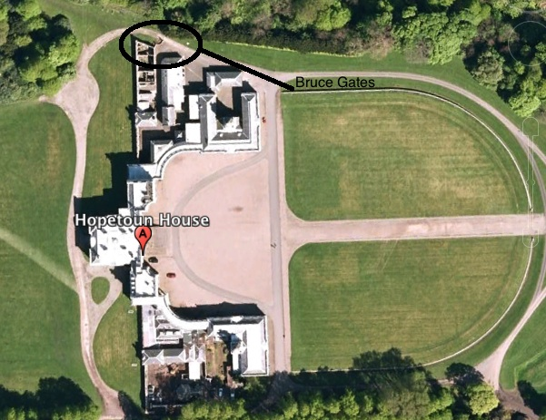

**Figure 3. Location of Bruce Gates within the Hopetoun House Estate**

The Bruce Gates are comprised of two large curved stonework bases with columns at the endpoints of each. In essence, each represents a quarter circle. The two bases are connected in the center by an ironwork gate. Each base also is connected to separate structures. The southern base is connected to the house and the northern base is connected to a stone wall that is on the edge of a minor cliff. In addition, the northern base has a wooden fence built up to its western facing exterior. This fence continues west, eventually making a 90-degree turn north before connecting to the stone wall that sits on the edge of the cliff. As a result, the western exterior of the northern stonework base is isolated in this sectioned off area. To access this portion of the gate, equipment and personnel were moved over the fence. Figure 4 shows an aerial view of the open Bruce Gates. The northern stonework base is blocked from view by overhanging trees and vegetation.

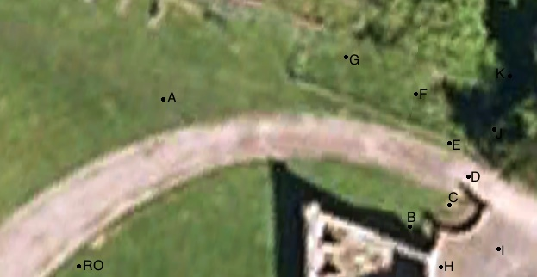

**Figure 4. Aerial view of Bruce Gates and station setups**

In addition to a general aerial view of the Bruce Gates, Figure 4 shows the approximate locations of each laser scanner station setup. Stations are labeled alphabetically in the order that data was acquired. Each of the 11 stations served a specific purpose in the acquisition of data about the Bruce Gates.

To begin the fieldwork, two stations were erected—RO and A. Station RO served as a reference object for the completed traverse. Laser scanning data was not observed at station RO. Instead, GPS coordinates were taken for orientation purposes when scanning to station RO at station A. GPS observations gave primary influence to the final location of station RO as it was required to be in the open, away from obstructions that would block the view to the sky. GPS readings were taken using an RTK GPS method. This method allows for reduced observation times and also for multiple readings. A total of five readings were taken. The average coordinate values of the readings were then calculated and used as the presumed coordinates for station RO. This process was repeated for station A. Its final location also was influenced by the requirement to observe GPS data, however, contrary to station RO, station A needed to have a line of site to station RO and station B. Using the presumed coordinates of station RO and station A, coordinates of all subsequent stations were calculated using the traverse method of laser scanning. Desired specification for misclosure of calculated coordinates for this project was 0.020m Table 1 displays the final calculated British National Grid coordinates of each station.

|  |  |  |  |  |
| --- | --- | --- | --- | --- |
| **British National Grid Coordinates of TLS Stations** | | | | |
| **Station** | **Eastings (m)** | **Northings (m)** | **Height (m)** | |
| **RO** | 308838.397 | 679087.206 | | 34.636 | |
| **A** | 308841.013 | 679122.668 | | 34.270 | |
| **B** | 308862.980 | 679115.103 | | 34.222 | |
| **C** | 308866.691 | 679116.799 | | 34.189 | |
| **D** | 308867.071 | 679119.510 | | 34.165 | |
| **E** | 308867.845 | 679121.838 | | 34.179 | |
| **F** | 308864.300 | 679125.668 | | 34.200 | |
| **G** | 308859.140 | 679125.724 | | 34.230 | |
| **H** | 308866.834 | 679111.712 | | 34.155 | |
| **I** | 308870.896 | 679112.511 | | 34.158 | |
| **J** | 308870.896 | 679112.511 | | 34.158 | |
| **K** | 308870.896 | 679112.511 | | 34.158 | |

**Table 1. British National Grid Coordinates of TLS Stations**

Data acquisition commenced with laser scanning at station A. A 360**°** scan was taken at a resolution of 0.020m. This resolution is significantly low for the applications being undertaken in this project. However, the laser scan data collected at station A was only used for frame of reference when viewing the collective point cloud from all stations and was not utilized in the creation of the three-dimensional models.

Next, data was collected at station B. Resolution was set at 0.002m, as this would be the necessary resolution for three-dimensional modeling and degradation monitoring. All subsequent scans also used this resolution. Unlike the scan at station A, a 360**°** scan was not taken. Instead, data collection was targeted at the west-facing stonework base at the southern portions of the Bruce Gates. Figure 5 details the exact area that was targeted by the scan.

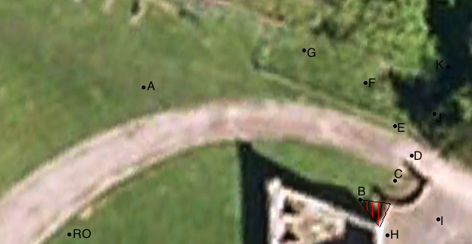

**Figure 5. Data acquisition from station B**

Data collection from station C targeted the inner, western facing, quarter circle of the stonework base on the southern section of the Bruce Gates. Areas of overlap data focused on one of the main stone columns on the left edge of the scan at station B. Figure 6 details the exact area that was targeted by the scan from station C.

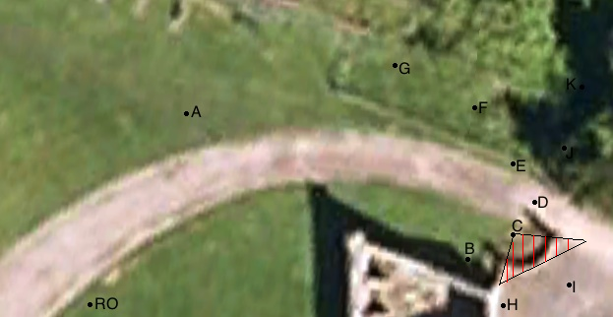

**Figure 6. Data acquisition from station C**

Laser scanning from station D focused on the iron gates. For this section, the gates were closed, limiting access between the western and eastern sections of the estate. As this was a targeted scan, total scanning time was limited to no more than 20 minutes. Overlapping data was focused on the two stone columns at either side of the iron gate. Figure 7 details the exact area that was targeted by the scan from station D.

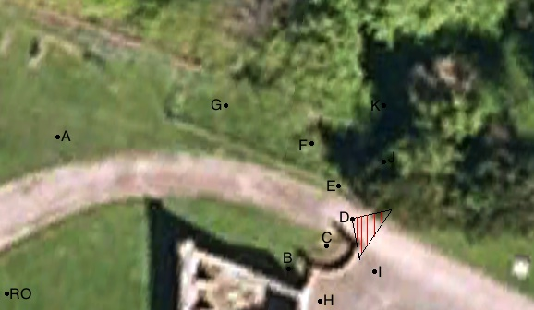

**Figure 7. Data acquisition from station D**

Data collection from station E targeted the inner, western facing, quarter circle of the stonework base on the northern section of the Bruce Gates. The setup for this station proved difficult due to the wooden fence. The optimum view of the columns and stonework happened to be exactly over a section of fence. To solve for this, the tripod was set up over the fence, with two legs being on one side and the other leg being on the opposite side. The fence also proved to interfere in the data collection, as it rested directly on a section of stonework. Stonework directly behind the fence would not have data captured due to the presence of the fence. Overlapping data was focused on the two stone columns on this section of the gate with the more southern column also being captured during the scan at station D. Figure 8 details the exact area that was targeted by the scan at station E.

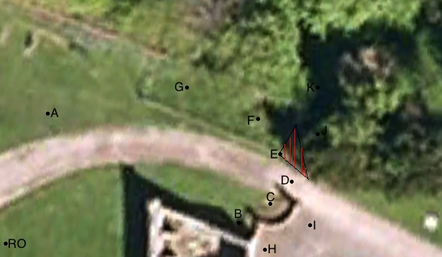

**Figure 8. Data acquisition from station E**

Station F served as the last scanning station to focus on the western facing portion of the Bruce Gates. It targeted a small section on the most northern column with overlap focusing on a column that was also captured during the scan at station E. This scan was also the first to capture data from the adjacent stone wall that extends west at the top of a minor cliff. This cliff may be the cause of the degradation to the stone wall as he entirety of the wall is beginning to lean in this direction. Due to this perceived deformation, data was collected on the wall in addition to the data collected on the Bruce Gates. Because a wooden fence enclosed station F, all equipment and personnel were carefully lifted over the fence one piece at a time. Figure 9 details the exact area that was targeted by the scan from station F.

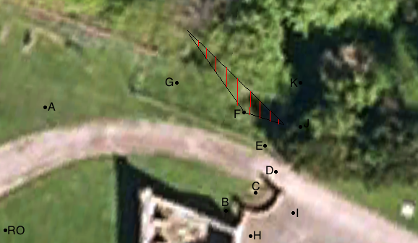

**Figure 9. Data acquisition from station F**

Data on the Bruce Gates was not collected at station G. Instead, its sole purpose was to acquire additional data on the stone wall. Overlapping data was collected from where the data at station F ceased. Scanning continued up to where the stone wall intersects with the wooden fence, which coincided with the most westerly extent of data capture of the Bruce Gates and the adjoining stone wall. Vegetative overgrowth was present with branches of trees coming over the top of the wall. Best efforts were taken to move all growth behind the wall, so it would not inhibit the capture of data and cause shadowing effects on the structure behind such vegetation. Figure 10 details the exact area that was targeted by the scan from station G.

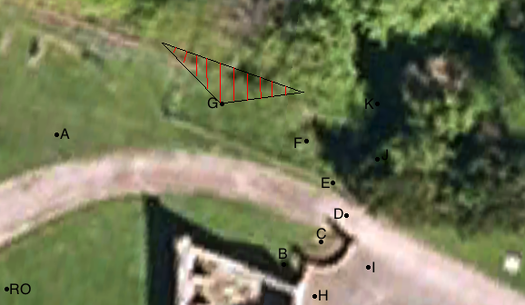

**Figure 10. Data acquisition from station G**

Data collection of the Bruce Gates continued at station H. At this station, the focus was a very small section of column where extreme angles at previous and subsequent stations would cause little to no data capture of this area. When setup of the station commenced, an error occurred in the calculation of the station’s coordinates. It was suspected that an incorrect target height was entered during the setup of station G, which caused the error. Due to this error, additional post processing was necessary and a rerunning of the traverse through Leica Cyclone was required. This error was promptly noted in the field notebook. Figure 11 details the exact area that was targeted by the scan from station H.

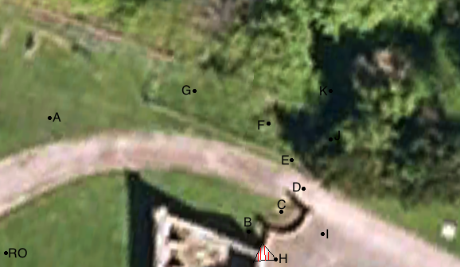

**Figure 11. Data acquisition from station H**

Data acquisition at station I proved to be the largest, both in area covered and total data collected. This section targeted the east-facing southern stonework base and the iron gates. As the northern section of the Bruce Gates is blocked by both vegetation and landscaped hedgerows, data capture was not able to go any further than the iron gates. A narrow line of site to station J was visible, but minimal areas of overlap were possible between the two stations. Overlapping areas were available with the scans at station H, consisting of scan data on the southern-most stone column of the Bruce Gates. As the scan also targeted the east-facing section of the iron gates, these gates needed to be completely shut, similar to the scanning from station D. Due to the large area covered, however, the iron gates were closed only during the last 10 minutes of the scan to leave access between the east and west areas of the estate open to visitors. Figure 12 details the exact area that was targeted by the scan from station I.

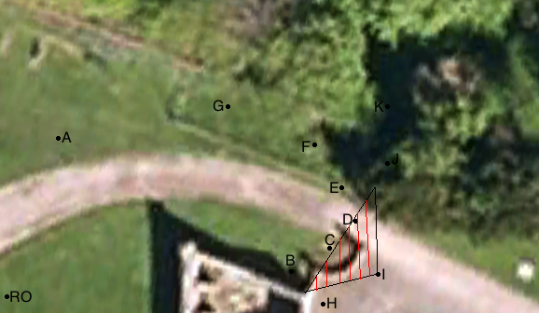

**Figure 12. Data acquisition from station I**

Unlike other station setups, two separate scans were taken from this station J. The reason was twofold. First, it reduced the total scanning time, as similar detail of the stonework base would be captured in full from station K. Second, station J had a restricted setup caused by a narrow line of site to station I and a limited working area due to vegetation overgrowth and the minor cliff, which forced the station to be set up extremely close to the stonework base. The limited downward capture angle of 45**°** did not allow for the full acquisition of data for this section of the base. With this in mind, the two areas where data could be captured were scanned over two separate sequences. The first scan sequence, the east-facing portion of the northern stonework base quarter circle, posed the most concern during data capture. This was due to the extreme angles forced by the positioning of the station and by a large wooden post installed in direct contact with this portion of the base. Any data capture in this area would be sparse and presumably would present countless holes once surface modeling commenced. The second scan sequence targeted the east facing northern extents of the stonework base of the Bruce Gates. Limited overlapping data with station I was expected, however, overlap with station K would be widely available due to common site lines. Figure 13 details the exact area that was targeted by the scans from station J.

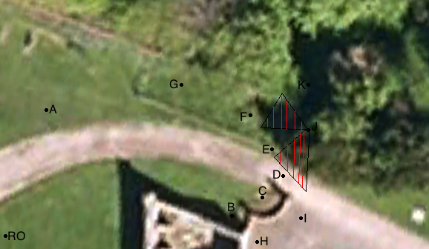

**Figure 13. Data acquisition from station J**

The last station setup and scan commenced at station K. The station’s location was placed as far back on the minor cliff as possible while still giving consideration to personal movement and station stability. The scan was set to cover a large area, with the intent to pick up details on the stonework base that were impossible to capture from station J, and as well as the backside of the stone wall that was captured at both stations F and G. Overall, coverage of the backside of the stone wall proved limited because of the vast amount of vegetative overgrowth in the area. Under optimal conditions, this vegetation would have been removed prior to fieldwork commencing. The unstable soil and minor cliff in this area proved unsafe for any major cleanup to occur. Data acquisition was limited to portions of the wall that were clear of any vegetation. This limitation caused large holes in the data and needed to be cut during the creation of the surface mesh to provide a smooth three-dimensional model. Figure 14 details the exact area that was targeted by the scan from station K.

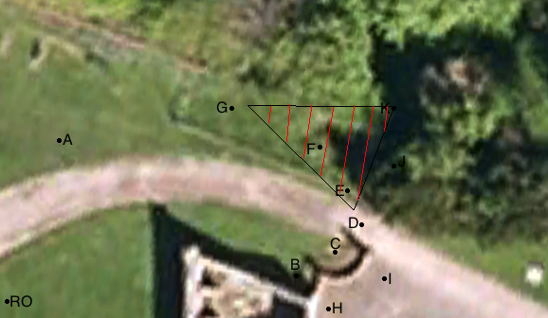

**Figure 14. Data acquisition from station K**

1. **Registration**

Using the traverse method of linking stations and scans together; registration of all acquired data from the fieldwork should have been minimal. The traverse method allows for the data to be linked together through the TLS scanner’s onboard software prior to data downloading. However, this did not work as anticipated.

Leica Cyclone Registration

After data was imported into Leica Cyclone, errors were obvious in how the scans aligned with each other. Data from stations H, I, J, and K appeared roughly 1.6m lower than the data points at the other stations. The error in target height at station G was noted during the fieldwork. With this considered, the cause of the error in data alignment was identified as an incorrect target height being input into the scanner in the field. Correction of the error was simplified once the cause was known. This error signifies the importance of comprehensive field notes taken during the course of the fieldwork. Ample field notes will add in the quick resolution of postproduction issues. Leica Cyclone has the ability to rerun the traverse within the software. Using data from each individual scan and notes of target heights recorded in the field notebook, the traverse was rerun to fix the height error.

The registration of data after rerunning the traverse, however, still showed error. A misclosure of approximately 8 meters was present in the final coordinates of the data captured from stations J and K, causing a massive misalignment of data with all previous stations. After several attempts to rerun the traverse, no clear reason for the misalignment was present. This may represent an error when entering new foresight and back sight targets during the setup of station J or a more unlikely possibility, an error in the onboard TLS software. Future fieldwork should focus on increased attentiveness when setting up new stations with the TLS. An alternative method then was used to correct for the error. As the rerun traverse was correct up until station I, the register data up to this point was kept. The registration of data from stations J and K was completed using the manual registration tool available in Leica Cyclone. This tool finds common targets that are present within both datasets and then aligns the datasets and merges them into one point cloud. The registration of the combined A through I data, with the J and K data posed the last hurdle in completing the registration of the point cloud. Manual registration using similar targets was not successful because of an error in the common targets between stations I and J. Only one option remained, which was to register the scans using manual point picking, a process in which the user selects common data points that are present between the two point clouds. Overlap was present between data collected at stations E and K. With a total of six overlapping data points collected, registration was successful and all data were combined into one data point cloud. Using this method, the misclosure of roughly 8.000m was reduced to 0.036m. While final misclosure of station J did not meet the desired specification of 0.020m, average misclosure over the entire traverse was 0.010m. Additionally, final misclosure values for the calculated station coordinates were computed. Table 2 displays the misclosure of each station.

|  |  |
| --- | --- |
| **Misclosure of TLS Stations** | |
| **Station** | **Misclosure (m)** |
| **A** | 0.017 |
| **B** | 0.013 |
| **C** | 0.011 |
| **D** | 0.015 |
| **E** | 0.006 |
| **F** | 0.002 |
| **G** | 0.003 |
| **H** | 0.005 |
| **I** | 0.001 |
| **J** | 0.036 |
| **K** | 0.001 |

**Table 2. Misclosure of TLS Stations**

CloudCompare Registration

With the registration of all scans completed successfully through Leica Cyclone, registration using the open source software, CloudCompare, could be instigated. Extensive research of the user manual, along with trial and error runs with CloudCompare showed that registration was limited to manual point picking. This method of registration is similar to that used in Leica Cyclone to register the scans of A through I with J. This meant the errors encountered with the raw registered data from the scanner could not be fixed by rerunning the traverse. Raw data from each individual scan needed to be registered with the scan at the next station in sequence. Although this is an acceptable method, it is labor intensive and time consuming in comparison to the method in Leica Cyclone. All scans were registered using manual point picking. Similar to the registration completed in Leica Cyclone, scans A through I were registered first. Scans J and K were then registered as there was little overlapping data present to connect the scan at J with the scan at I. Finally, scans A through I were registered with the scans of J and K, using overlapping points that were present in the scans at station E and station K.

While the registration of acquired data was possible with both sets of software, it became obvious Leica Cyclone offered multiple advantages over CloudCompare, including multiple registration methods. While all data could have been registered using manual point picking, as was done in CloudCompare, Leica Cyclone’s ability to rerun a traverse, use manual registration algorithms, and manually pick points saved both time and labor, which are highly valuable resources on projects with strict timelines and limited manpower. To fully utilize these tools, however, experience with Leica Cyclone is needed as is extensive troubleshooting experience to resolve multiple errors and misalignments. With a minimal budget and training, CloudCompare offers a simplistic though time-consuming tool to register multiple scans together. The process of manually picking overlapping points in data sets is easy but requires a significant amount of labor.

* 1. **Data Cleanup**

After registration is complete, the next step is to clean the point cloud data. This is done to sharpen the focus on the structure of interest and to facilitate the completion of surface modeling. Both Leica Cyclone and CloudCompare have tools to aid data cleanup. The tools are very similar and have the ability to delete individual data points or large sections of points.

The data acquired from the TLS of the Bruce Gates contain large amounts of data that is unnecessary for the creation of a three-dimensional model. This unwanted data consists of vegetation, fences, unrelated buildings, and general noise picked up by the laser scanner. Using Leica Cyclone, data was removed from the data point cloud using the fence tool. The fence tool creates a polygon and then deletes all data points within its boundaries. Vast sections of the point cloud were removed until only the structure of the Bruce Gates remained. At this point noise, the majority of which was concentrated around the iron gate and poles, was removed. Due to the compact nature of the gate structure, data cleanup needed to be precise to keep the parts of the structure needed for the model creation. This process, while labor intensive, was necessary to isolate the wanted structure from the surrounding point cloud and prepare it for the final stages of production. Figure 15 shows the Bruce Gates after data cleanup was completed in Leica Cyclone.

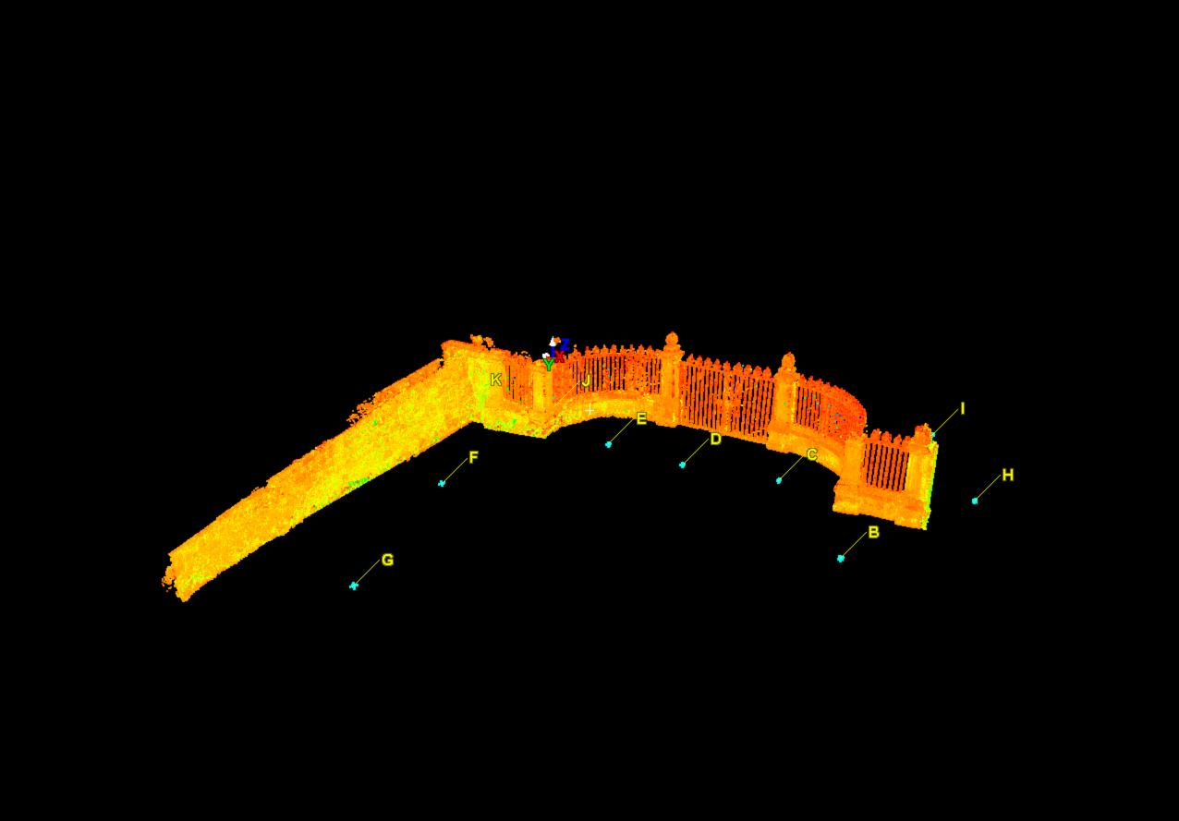

**Figure 15. Bruce Gates post data cleanup via Leica Cyclone**

During data cleanup with Leica Cyclone several issues presented themselves, including extreme frame rate slowing, delayed data refreshing, and complete software crashing. All of these issues were caused by the incompatibility of the hardware and software. Specifically, the hardware did not have the processing power to handle the three-dimensional software. Ultimately, data cleanup proved to be more labor intensive as the processing power of the hardware diminished. Pivoting, scrolling, and zooming were severely delayed when shifting the point of view to a different section of the Bruce Gates. After each data section removal, all data reloaded on the screen, often taking up to 30 seconds before functionality returned. At other points in the data cleanup, the software completely crashed and on multiple occasions led to a complete hardware reboot. Despite these setbacks, data cleanup was successful, though time consuming.

Data cleanup tools within CloudCompare are similar in functionality to those in Leica Cyclone. Like the fence tool in Leica Cyclone, CloudCompare’s tool allows the user to create a polygon around a section of interest and then delete the section within its set boundaries. Due to this, data cleanup involved deleting vast sections of the data point cloud to isolate the structure of the Bruce Gates. Once this was accomplished, data cleanup involved removing noise picked up by the laser scanner in the more intricate and compact areas of the structure. Similar to the Leica Cyclone, this process was labor intensive and required careful cleanup to avoid deleting necessary components of the Bruce Gates. Figure 16 shows the Bruce Gates after data cleanup was completed in CloudCompare.

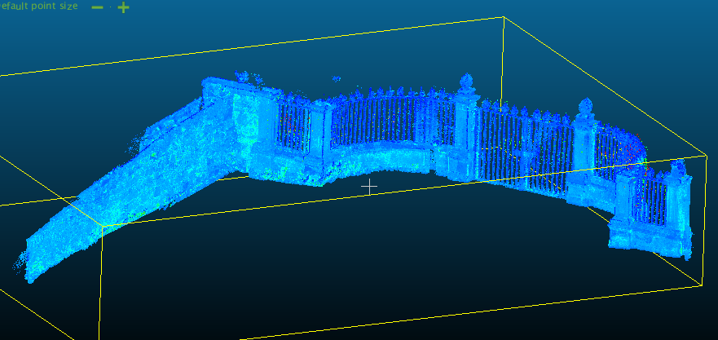

**Figure 16. Bruce Gates post data cleanup via CloudCompare**

In regards to the data cleanup process, differences between Leica Cyclone and CloudCompare were minimal. The software tools, while having different names, used similar methods, namely the creation of polygons around areas of interest followed by the deletion of the data points within the polygon boundaries. The overall process proved almost identical with no advantages of one software over the other during completion of data cleanup. Concerns over software and hardware compatibility did arise during this phase of production. The overall complexity of Leica Cyclone requires a more robust hardware with enhanced processing power. CloudCompare, with a simpler data point cloud editing software, was more compatible with hardware that lacked processing power. During data cleanup with CloudCompare, there were no issues of frame rate slowing, delayed data refreshing, or complete software crashing. Ideal hardware needed for seamless production in Leica Cyclone would include a quad core processor, 8GB RAM, and a high-powered graphics card. However, it should be emphasized that computer hardware owned by organizations such as the Trust are more likely to be compatible with CloudCompare. All external factors being equal and potential hardware being compatible with the user’s software requirements, data cleanup should prove seamless whichever software package is used.

* 1. **Surface Meshing**

With data cleanup of the point cloud complete and the structure of the Bruce Gates isolated, the next step was to create a surface mesh. The mesh allows distinct data points to be combined into a unified and solid surface, which becomes a representation of the Bruce Gates based on the type of surface mesh algorithm used. It is at this stage that key differences between Leica Cyclone and CloudCompare are evident. Each offers unique methods to create a surface mesh, resulting in noticeable differences in the final representation of the structure.

The process of creating the surface mesh in Leica Cyclone was simple. By selecting individual point clouds associated with a laser scanner station setup, the surface mesh creation tool creates a mesh for that particular section. At this point, there are several meshing options available, each using different algorithms to create a surface that best represents the individual point cloud selected. These options boil down to two basic types of meshing algorithms, one connects all data points in the point cloud directly while the other attempts to build a best-fit surface based on predetermined weights given data points depending on the distances between each other.

To create a directly connected surface mesh, Leica Cyclone uses a Triangulated Irregular Network (TIN) algorithm. This algorithm creates triangles between all available data points to represent the true surface of a structure. However, it does not differentiate between random noise or the complex areas of a structure that are in close proximity but do not physically connect. For a structure such as the Bruce Gates, this potentially leads to significant misrepresentation of the true surface, as areas such as the iron gates would be physically joined together in places in which they are not in reality. As a result, the TIN method for surface meshing of the Bruce Gates was not suitable for the creation of a three-dimensional model. Figure 17 demonstrates how the TIN method represents the Bruce Gates.

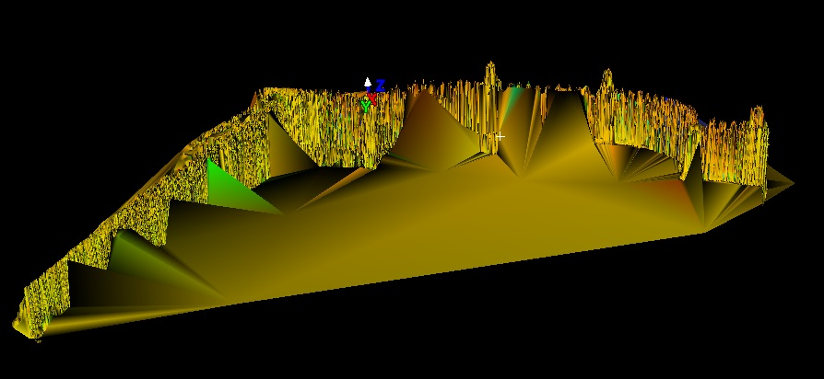

**Figure 17. Leica Cyclone TIN Mesh**

A best-fit surface mesh was created with the help of the Complex Meshing tool within the mesh creation toolbox in Leica Cyclone. This option determines the best possible fit for a surface to represent the Bruce Gates. To achieve this, predetermined weights are assigned to corresponding data points throughout the point cloud. Data points with larger weights have more bearing on the location of the surface mesh while lower weights, such as those associated with random noise in the data point cloud have little bearing on its final position and shape. It should be noted that this method for surface mesh calculation never truly represents the actual surface of the structure in question, but can provide an improved representation compared to a TIN surface mesh because it ignores random noise and can distinguish unique fixtures that may be in close proximity. There also is a greater cushion for error should data cleanup in the previous phase of production not be perfect. Due to these factors, a best-fit surface mesh offers the best representation of the Bruce Gates for the creation of a three-dimensional model.

After the creation of the surface mesh, holes in the surface became apparent due to a lack of data in a particular area. In the case of the Bruce Gates, fences and vegetation often blocked views of the structure resulting in little to no data being captured directly behind an object. Extreme angles between the structure and the laser scanner, such as occurred at stations, J and I, due to a hedgerow that obstructed optimal views, thus capturing diminutive data on sections of the structure and station I recorded.

Leica Cyclone has a hole-filling tool to fix apparent gaps in the data. Small holes, which are frequent in the created surface mesh, are easily filled using the vast amount of surrounding data. However, due to the size and nature of some holes, filling cannot be completed because there is not enough information available to the tool to create a new surface. This issue occurred at two particular sections of the Bruce Gates. First, from station E, the section of the stone structure with an adjacent wooden fence could not be filled. A large hole was left due because the fence could not be moved during data acquisition. Secondly, a large hole was present in the stone base in between stations I and J due to the extreme angles between the laser scanner and the stone base caused by the obstructed views of the hedgerow. These holes, while causing a suboptimal three-dimensional model, could not have been avoided due to the nature of the structure and the physical obstructions in its immediate surroundings. Like any TLS project, the avoidance of holes is near impossible due to the nature the site.

The last phase of the three-dimensional model creation was the overlay of photorealistic texture and color. With the help of the laser scanner used for this project, panoramic photos were recorded from each setup station, capturing the natural color and texture of the Bruce Gates. The Leica Cyclone has the ability to overlay these photos on the surface mesh. With a simple click, the surface mesh changes color from a generic color map to that of the actual structure. This transformation, while simple, transforms a three-dimensional model into a realistic representation of the Bruce Gates. Figures 18 and 19 show the final three-dimension model created with Leica Cyclone.

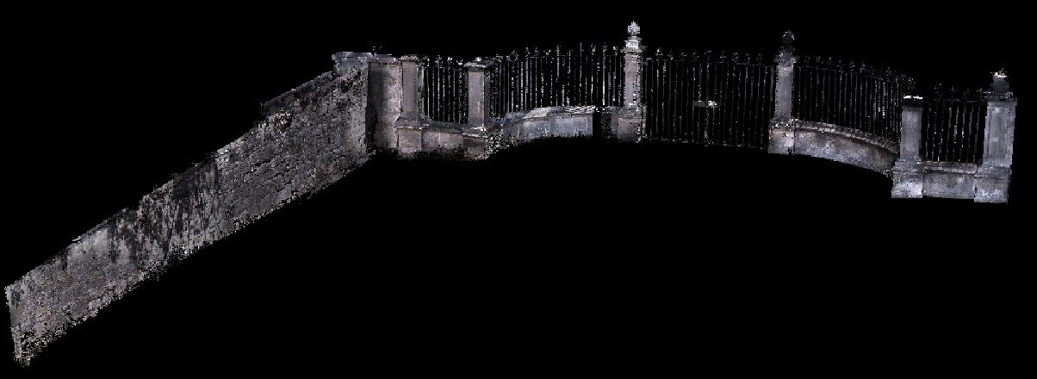

**Figure 18. View of Bruce Gates looking east**

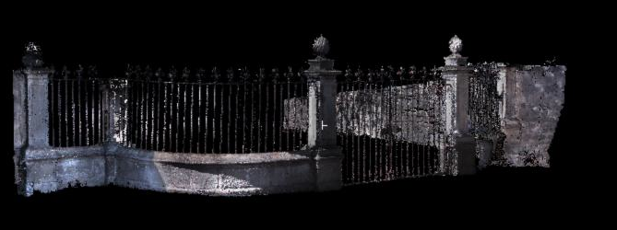

**Figure 19. View of Bruce Gates looking west**

CloudCompare, like its counterpart, has multiple methods in its toolbox for calculating surface meshes. These methods fall into the same categories of algorithms that were seen with Leica Cyclone. One connects all data points in the point cloud directly while the other attempts to build a best-fit surface based on predetermined weights given to data points depending on the distances between each other. A test of the best-fit method determined that the algorithm was too simplistic to create a complex mesh to represent a structure such as the Bruce Gates. The algorithm attempted to create a singular mesh surface that followed a one-dimensional plane. Figure 20 shows the best-fit mesh created in CloudCompare. The green surface represents the created mesh overlaid on the data point cloud. As can been seen, the mesh cuts directly through the entire set of data in the horizontal plane.

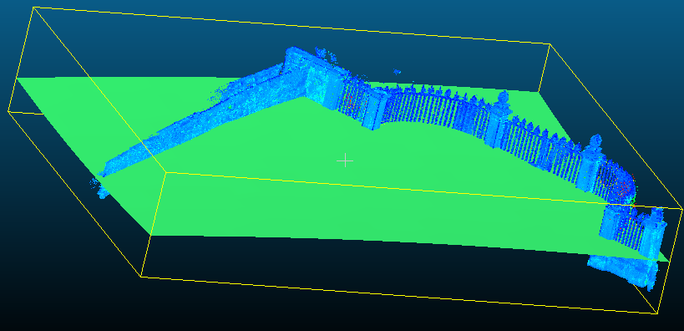

**Figure 20. CloudCompare best-fit mesh**

With the inability of the best-fit mesh to represent the Bruce Gates, a direct-fit mesh remains the only option within CloudCompare. This direct-fit mesh is very similar to the TIN method used within Leica Cyclone. A surface is formed through the creation of triangles between data points throughout the point cloud. This similarity also causes it to suffer from the same drawbacks. The model does not differentiate between random noise and the actual structure, which leads to significant misrepresentation of the true surface, such as the iron gates. This method causes the gates to be physically joined together in places where they are not in reality. Figure 21 demonstrates this by showing the iron gates. A surface is created in between the individual posts, when in reality this is open space with no obstructions.

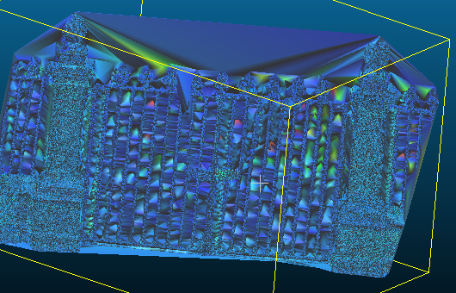

**Figure 21. CloudCompare direct-fit mesh**

This type of direct-fit mesh does not have the ability to represent the Bruce Gates due to the complexity of the structure in combination with the simplicity of the mesh algorithm. CloudCompare should not be used in its current capacity when three-dimensional representations of complex structures are required. However, CloudCompare does have the ability to model more simplistic features. During testing, portions of the stone wall adjacent to the minor cliff were meshed using the direct-fit method available in the software package. With the simplistic nature of the stone wall the direct-fit mesh gave a reasonable representation of the true structure.

A comparative look at the best-fit mesh from Leica Cyclone on this same section of wall showed that while Leica Cyclone’s advanced algorithms gave an incredibly realistic representation of the wall, CloudCompare’s direct-fit mesh gave a comparable representation. Each iteration gives the user the ability to differentiate between individual stones and even represents protrusions coming from the wall. Figures 22 and 23 show the direct-fit meshes from each software packages on the same section of the stonewall. In a project focusing on simplistic structures, CloudCompare’s direct-fit mesh has the ability to viably represent a three-dimensional model.

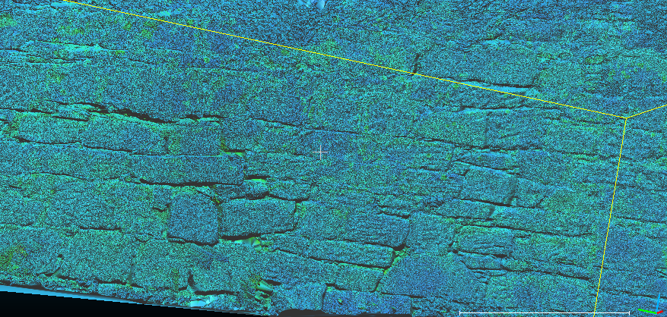

**Figure 22. CloudCompare direct fit of stone wall**

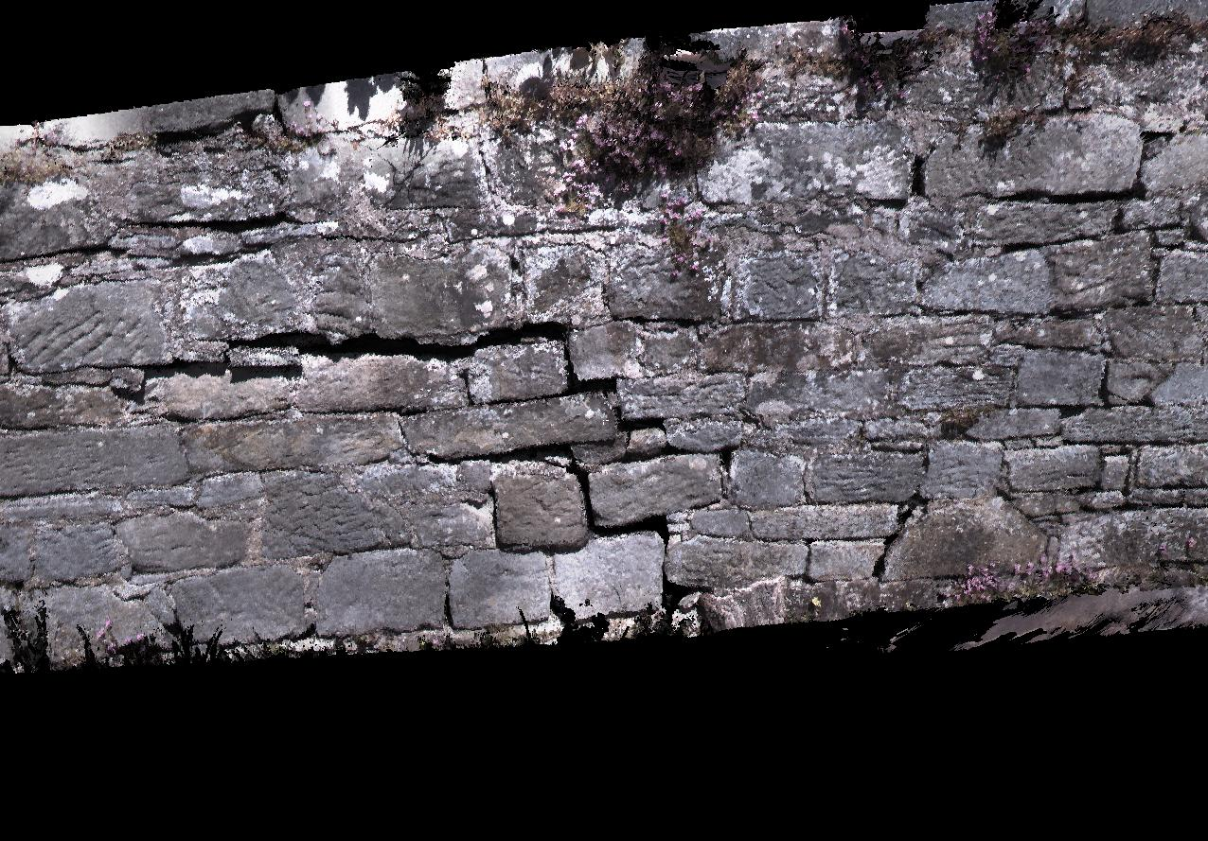

**Figure 23. Leica Cyclone best-fit of stone wall**

Further use of CloudCompare’s modeling tools reveals a lack of photo overlay in the creation of a three-dimensional model. Should a direct fit mesh be suitable for a structure of interest, the option to overlay photorealistic texture and color is not an option. This limits the software as an alternative to Leica Cyclone for the purpose of creating a three-dimensional model.

It is at this stage in production that clear differences between Leica Cyclone and CloudCompare become apparent. The latter is limited by its simplicity when creating meshes. This restricts it to the modeling of simplistic structures such as the stone wall attached to the Bruce Gates. Leica Cyclone has the capacity to create meshes that give a realistic representation of increasingly complex structures. In addition to photorealistic coloring and texture overlay, the creation of a geometrically accurate three-dimensional model is possible. However, even Leica Cyclone has its limitations. The software has trouble creating models of elaborate features, such as the ornate spikes atop of each of the iron gate posts. While rough models of these spikes are created with the meshing tools, it cannot produce a true geometrically correct representation. The ability to create such a representation requires additional software that is dedicated to the function of three-dimensional model creation. Both Leica Cyclone and CloudCompare are lacking in this area as development of each software package has created multifaceted products with tools capable of registration, data cleanup, surface meshing, and others related to terrestrial laser scanning and surveying. Their focus on a broader set of tools has led to their suboptimal production of three-dimensional models.

1. **Chapter Six: Conclusion**

The production of three-dimensional models of the Bruce Gates using Leica Cyclone and CloudCompare shed light on the digital conservation and degradation monitoring capabilities of TLS and its application in both software packages. Although each package performs similar functions, the application of each package during the Bruce Gates project highlighted the clear differences that affect the value of the application to end users, such as the Hopetoun House Preservation Trust.

The Leica Cyclone package provided modern and professional tools that serve as a functional platform to fully process point cloud data obtained through the use of TLS. The software is complex, however, requiring a moderate level of familiarity to fully utilize its potential and hardware with robust processing power. The Trust, while knowledgeable in historic conservation, currently does not possess the hardware, skills, and personnel to operate this software. To fully utilize the capabilities of Leica Cyclone, the Trust would need to train one of its own staff or hiring an external consulting firm and purchase upgraded hardware to complete any further data processing.

In addition, Leica Cyclone has limitations that may handcuff the Trust in its desire to create and manage realistic three-dimensional models of the estate. While capable of creating a three-dimensional model, the results of this project demonstrate that it lacks the ability to model ornate objects such as the elaborate spikes atop each of the iron posts of the Bruce Gates. The modeling resulted in overly simplistic and often misrepresented depictions of the structures. In the final model creation, for example, while not detracting from the final visual outcome, close inspection shows a slight misrepresentation of the shape of the spikes atop each iron post. The Hopetoun House Estate contains a vast array of ornate objects. Further digital conservation of the estate will require additional highly functional three-dimensional modeling software that is solely dedicated to capturing ornate objects. For this reason, the necessity for additional software may arise resulting in additional costs.

Finally, the use of Leica Cyclone revealed an absence of tools to monitor structural degradation. While the software can maintain the baseline data of the Bruce Gates, there is no tool that allows for comparison with data acquired at any point in the future. Should the Trust pursue continued monitoring and subsequent intervention of deformation for either the Bruce Gates or other Hopetoun House structures, Leica Cyclone is not capable of this task. To fully undertake future projects of digital conservation and degradation monitoring on the Hopetoun House estate, investment into infrastructure consisting of laser scanning software and equipment, three-dimensional modeling software, degradation monitoring software, and staff training will be necessary. All of which requires a significant budget to fully implement.

Conversely, the utilization of CloudCompare software reduces investment in infrastructure, specifically the laser scanning and degradation monitoring software. This is due to the availability of basic tools and functions provided by CloudCompare, including registration and data cleanup. While these are available features in Leica Cyclone, for simple projects such as the creation of baseline data for a structure, CloudCompare enables a new user with no experience to produce a singular point cloud. It is when more complex functionality is essential, however, that CloudCompare fails to meet the requirements of many digital conservation projects. These complex functions included the creation of surface meshes to represent ornate structures, the ability to fill holes in a surface mesh, and a facility to apply a photo overlay for photorealistic coloring. While surface meshing and modeling are available through CloudCompare, they are severely limited in capability and can only handle the modeling of simplistic structures.

Cloud compare proved suitable for modeling the outer surface of the stone wall adjacent to the Bruce Gates, but the software failed to represents any of the increasingly complex elements of the Bruce Gates structure in a realistic fashion. It is at this junction in production that dedicated three-dimensional software packages must be employed to pick up the capabilities that lacking in both CloudCompare and Leica Cyclone.

To create and display the truly ornate features of the Bruce Gates, investment beyond the initial TLS software will be essential. Three-dimensional software packages such as 3dReshaper and 3dsmaxx show potential, but significant training in each is needed for full utilization. Trials with both software packages during this project did not produce representative models of the ornate spikes. Access to tutorials or training materials for either software would have led to a more visually appealing model.

CloudCompare does offer one feature that Leica Cyclone does not. CloudCompare has the ability to compare point cloud data and monitor degradation over time. This could prove useful for the Trust as it can use of the baseline data created for the Bruce Gates during this project should it acquire additional TLS data. This feature, combined with the relatively simple user interface and lack of licensing costs, would allow the Trust to monitor the Bruce Gates for degradation without any investment into specialized software or hardware. For these reasons, CloudCompare should be an essential tool in any future degradation monitoring and research undertaken at the Hopetoun House Estate.

While neither software package encompasses all the necessary tools required for digital conservation and degradation monitoring, each provides essential functions vital for the early stages of data capture and production. A final recommendation for the Trust and similar organizations would be to work closely with the developers of open source software, notably CloudCompare, to cultivate an all-inclusive package with the ability to fully register, clean, mesh, model, and overlay data from TLS to create accurate three-dimensional models of all features, as well as monitor degradation over time.

As a result of this project, the Trust has the opportunity to engage with CloudCompare to create a unique and exciting solution that can aid in the continued digital conservation of the Hopetoun House Estate. The continued development of CloudCompare for utilization by a privately funded historic trust opens the door for similar organizations throughout Scotland and the United Kingdom to accomplish related goals. The continued conservation of private historic and cultural sites is reliant upon continued access to research to develop cost-effect conservation solutions. This is particularly true for privately funded organizations that often lack financial and professional support and may become increasingly important for the conservation of government-funded historic sites as well.

This project established an up-to-date digital record of the Bruce Gates, which will enable the continued study of the degradation of the structure and provide the Trust with digital documentation for use on brochures and materials about the degradation monitoring the Trust wishes to undertake in the future. In the future, the inclusion of geo-referenced data in the data point cloud of the Bruce Gates could aid in the registration of an all-encompassing three-dimensional model of Hopetoun House. Such a full-scale model would be one of the first completed by a private estate or trust.

As the Trust pursues comparative research on the degradation of the Bruce Gates continued contact with CloudCompare developers to add and upgrade features introduces the possibility of the Trust becoming a leader in the digital conservation of privately held historic sites. Recommendations for future TLS data acquisition would be annual studies of the Bruce Gates for comparison to the original baseline data created as a by-product of this project. Ultimately, continued research of the Bruce Gates will lead to a more comprehensive understanding of the degradation of this historic sites. Continued exploration into digital conservation and degradation monitoring at Hopetoun House will benefit all patrons involved in safeguarding historic and cultural sites.

Access to hardware with higher processing power and workshops on dedicated three-dimensional software packages would have improved the final three-dimensional model of the Bruce Gates, in particular the representation of the ornate spikes on the iron gates. However, the three-dimensional modeling of the Bruce Gates and the comparative study of open source software for the application of digital conservation and degradation monitoring in the end proved beneficial. The Hopetoun House Preservation Trust has initial data on the Bruce Gates that it can use in the future to monitor the degradation to the gates and a start on the TLS data capture on other structures on the historic site. With time and focus, the Trust has the ability to work with the developers of CloudCompare to develop a robust software that meets its needs and those of similar trusts throughout the United Kingdom. The Trust also has information on the hardware, specialized software packages, and staff requirements required to continue this research.

# Bibliography

Al-kheder, S., Al-shawabkeh, Y. & Haala, N., 2009. Developing a documentation system for desert palaces in Jordan using 3D laser scanning and digital photogrammetry. *Journal of Archaeological Science*, 36(2), pp.537-46.

Blue Ribbon Task Force, 2010. *Sustainible Economics for a Digital Planet: Ensuring Long-Term Access to Digital Information*. La Jolla, CA, USA: Blue Ribbon Task Force on Sustainable Digital Preservation and Access.

Brizzi, M. et al., 2006. 3D Laser Scanning as a Tool for Conservation: The Experiences of the Herculaneum Conservation Project. In Ioannides, M., Arnold,

Cignoni, P., Montani, C. & Scopigno, R., 1997. *A comparison of mesh simplification algorithms*. Pisa, Italy: Istituto di Elaborazione dell’Informazione.

Chee Wei, O., Siew Chin, C., Majid, Z. & Setan, H., 2010. 3D DOCUMENTATION AND PRESERVATION OF HISTORICAL MONUMENT USING TERRESTRIAL LASER SCANNING. *Geoinformation Science Journal*, 10(1), pp.73-90.

CloudCompare, 2012. *CloudCompare*. [Online] Available at: <http://www.danielgm.net/cc/> [Accessed 29 June 2013].

CloudCompare, 2013. *CloudCompare Versions History*. [Online] Available at: <http://www.danielgm.net/cc/release/history.txt> [Accessed 29 June 2013].

D., Niccolucci, F. & Mania, K., eds. *The 7th International Symposium on Virtual Reality, Archaeology and Cultural Heritage VAST*. Nicosia, Cyprus, 2006. Eurographics Association.

Eakin, L., Friedlander, A., Schonfeld, R. & Choudhury, S., 2008. *A Selective Literature Review on Digital Preservation Sustainability*. Blue Ribbon Task Force on Sustanible Digital Preservation and Access.

Firestone, E., 2008. *AN EXPLORATION OF HOLE FILLING ALGORITHMS*. Master's Thesis. San Luis Obispo, CA, USA : California Polytechnic State University.

Girardeau-Montaut, D., Roux, M., Mare, R. & Thibault, G., 2005. CHANGE DETECTION ON POINTS CLOUD DATA ACQUIRED W ITH A GROUND LASER SCANNER. In *ISPRS Workshop Laser Scanning*. Enschede, Netherlands, 2005. ISPRS.

Historic Scotland, 2013. *The Scottish Ten*. [Online] Available at: <http://www.historic-scotland.gov.uk/index/heritage/technicalconservation/conservation-initiatives/laserscanning.htm> [Accessed 1 May 2013].

Hong Kong Heritage, 2012. *Historic Buildings @ Heritage.Conservation*. [Online] Available at: <http://www.amo.gov.hk/en/teachingkit/rom/elink/ech1/ech1.pdf> [Accessed 1 May 2013].

Hopetoun House Preservation Trust, 2013. *The Trust*. [Online] Available at: <http://www.hopetoun.co.uk/the-trust.html> [Accessed 2 May 2013].

IFAP Working Group on Information Preservation, 2010. *Open Source Software for Digital Preservation and Data Managment*. United Nations Educations, Scientific and Cultural Organization.

Kimpton, G.R., Horne, M. & Heslop, D., n.d. *TERRESTRIAL LASER SCANNING AND 3D IMAGING: HERITAGE CASE STUDY – THE BLACK GATE, NEWCASTLE UPON TYNE*. Northumbria University.

Lee, D.T. & Schachter, B.J., 1980. Two Alogorithms for Constructiong a Delaunay Triangulation. *International Journal of Computer and Information Science*, 9(3).

Manitoba Goverment Historic Resources Branch, 2009. *Benefits of Heritage Building Conservation*. [Online] Available at: <http://www.gov.mb.ca/chc/hrb/benefits.html> [Accessed 1 May 2013].

Paumier, S., 2009. WHY ACADEMIC SOFTWARE SHOULD BE OPEN SOURCE. *INFOTHECA – Journal of Informatics and Librarianship*, 10(1), pp.51-54.

Rüther, H. et al., 2011. *Challenges in Heritage Documentation with Terrestrial Laser Scanning*. Zamani Research Group, Geomatics Division, University of Cape Town.

Vela, E. et al., 2010. Terrestrial laser scanning for the digital preservation of a Croatian historical village “Dobranje”. In *Facing the Challenges – Building the Capacity*. Sydney, Australia, 2010. FIG Congress 2010.